Client Map Instructions

1. First unzip the downloaded zip file.
2. Go inside the folder and double click on mas-client-map.exe file. (Internet connection required)

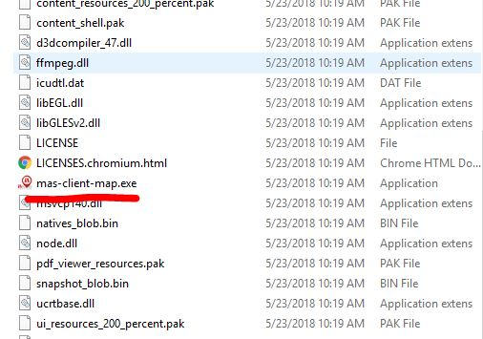

1. Then system open up with the currently available client markers.
2. Hover the mouse on below icon

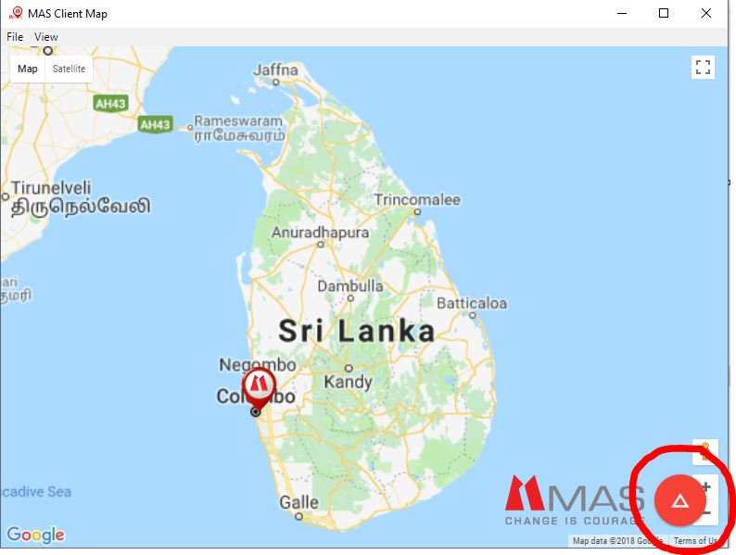

1. The you can see the functionalities of the system.

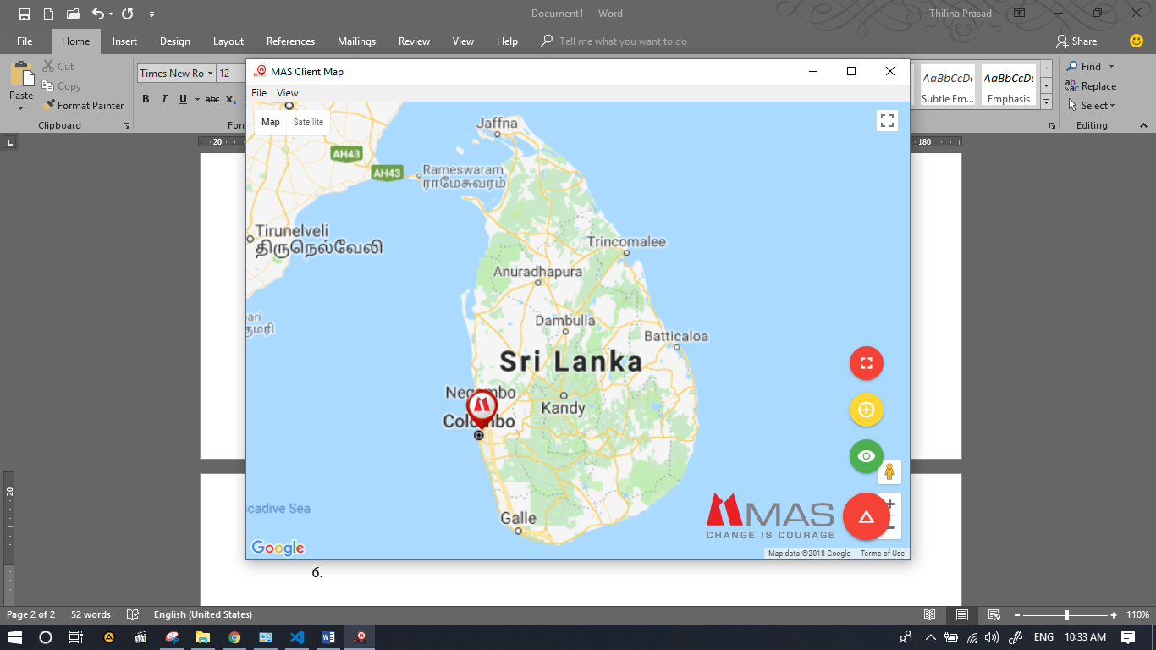

1. When you adding new location select the .ppt, .ppsx, .ppt, .pps but the recommended file type is .ppsx.